

## Department of Computer Science & Engineering

Rajshahi University of Engineering & Technology

# LAB REPORT

## Topic: Shell Script (Conditional Statements, Loops)

## Course No: CSE 3202

## Course Name: Sessional Based on Operating Systems

Submitted By

Saifur Rahman

Roll No: 1703018

Section: A

CSE, RUET

Submitted To

Mohiuddin Ahmed

Lecturer

CSE, RUET

Date of Lab: 21st Mar 2022

Date of Submission: 4th Apr 2022

Contents

Program Topic: Arithmetic Operations 1

Program Topic: Even/ Odd Determination 2

Program Topic: Generating Prime Numbers within a Range. 3

Discussion: 4

### Program No. 1

### Program Topic: Arithmetic Operations

#### CODE

*#! /bin/bash*

**read** -p "Enter a: " a

**read** -p "Enter b: " b

**echo** "Addition:" $**((**a+b**))**

**echo** "Subtraction:" $**((**a-b**))**

**echo** "Multiplication:" $**((**a**\***b**))**

**echo** "Division:" $**((**a**/**b**))**

**echo** "Remainder:" $**((**a**%**b**))**

#### OUTPUT

#### 

### Program No. 2

### Program Topic: Even/ Odd Determination

#### CODE

*#! /bin/bash*

**read** -p "Enter an integer: " x

**if** **[** $**((**x**%**2**))** -eq 0 **]**

**then**

**echo** $x is even

**else**

**echo** $x is odd

**fi**

#### OUTPUT

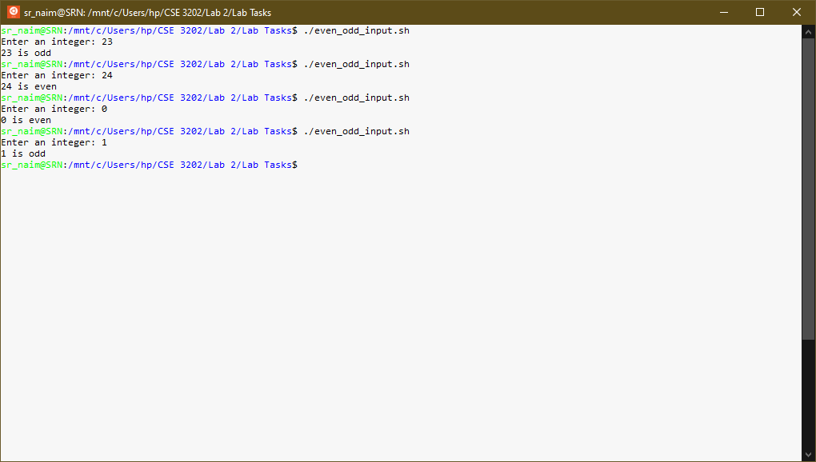

### Program No. 3

### Program Topic: Generating Prime Numbers within a Range.

#### CODE

*#! /bin/bash*

c=0

**read** -p "Enter starting number: " s

**read** -p "Enter ending number: " e

**for** **((**i=s;i**<**=e;i++**))**

**do**

**for** **((**j=2;j**<**i;j++**))**

**do**

**if** **[** $**((**i**%**j**))** -eq 0 **]**

**then**

c=$**((**c+1**))**

**fi**

**done**

**if** **[** $c -eq 0 **]** **&&** **[** $i -ne 1 **]**

**then**

**echo** $i

**fi**

c=0

**done**

#### OUTPUT

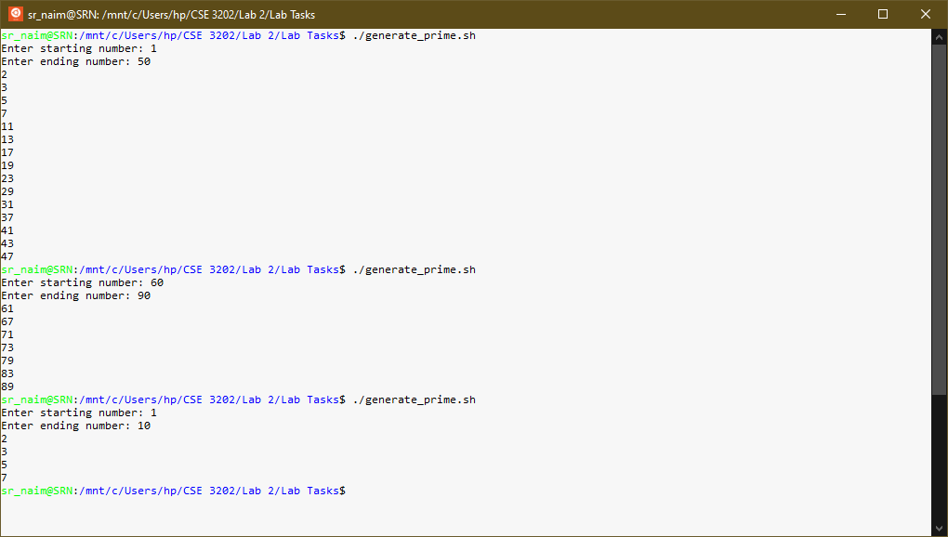

### Discussion:

* To read user input with a prompt message we use this command.

read -p “Message” variable

* To calculate arithmetic operations, we need to use double first brackets followed by a dollar sign

$((a+b))

* For if else conditioning, we need to be careful about the condition and bracket orientation. There must a space after the starting and before the ending of 3rd bracket

if [ condition ]

then

#code

else

#code

fi

* For loop operations, indexing is mandatory as no brackets are used.

for ((start;condition;stepsize))

do

#code

done